GUIDE TO MANAGING RISKS OF EXPOSURE TO DIESEL EXHAUST
IN THE WORKPLACE
This Guide provides information on how to manage risks associated with exposure to diesel exhaust in the workplace.
Information on diesel exhaust exposure in the mining sector is available in mining specific guidance.

What is diesel exhaust?
Diesel exhaust comes from engines burning diesel fuel. It is a complex mixture of gases, vapours, liquid aerosols and particulate substances. These substances are the products of combustion. The main chemical components of diesel exhaust emissions are:
- Gases and vapours – these are mostly the gases found in air like nitrogen, oxygen, water vapour and carbon dioxide. There are also hazardous chemicals like nitrous oxide, nitrogen dioxide, sulphur dioxide and carbon monoxide.
- Fine particles known as diesel particulate matter (DPM) including fine carbon particles – hazardous chemicals known as poly aromatic hydrocarbons (PAHs) adhere to the surface of carbon particles.
DPM can act like a gas and stay airborne for long periods of time. DPM can penetrate deep into the lungs because of its small size.

Workplace exposure to diesel exhaust
The major source of workplace exposure to diesel exhaust is from heavy vehicles that use diesel fuel like trucks, buses, trains, tractors, ships, bulldozers and fork lift trucks. Other sources include equipment in mines, bucket lifts and excavators. All motor vehicles that use diesel fuel generate diesel exhaust when running including during workshop repair or servicing, in car parks, when passing toll booths or in vehicle holds in ships and trains.
Diesel exhaust may also be generated from stationary power sources like generators and winch motors including those mounted to vehicles. These may be used in tunnels, alongside railway lines during maintenance work and on construction sites.
Levels of exposure can be higher in enclosed, poorly ventilated areas where the concentration of exhaust can build up like in vehicle repair workshops, tunnels, partially covered roadways and walkways.
Workers who may be exposed to diesel exhaust include drive-in booth operators, miners, construction workers, oil and gas workers, airline ground workers, forklift drivers, loading dock workers, truck drivers, farmworkers, stevedores and vehicle maintenance workers.
Research has estimated 1.2 million Australian workers were exposed to diesel exhaust in the workplace in 2011.

Incidental exposure to diesel exhaust
Incidental exposure refers to situations where the source of diesel exhaust is not under the control of the workplace. This exposure needs to be minimised.
Workers at risk of incidental exposure may include workers who spend a significant amount of time around trucks that are unloading and loading and diesel-powered plant and machinery. Other workers at risk of incidental exposure include workers who carry out work near busy railway lines and roadways, workers in takeaway outlets, toll booth operators, traffic controllers, car park attendants and material handling operators.

What are the health effects of exposure to diesel exhaust?
Exposure to diesel exhaust can cause both short-term (acute) and long term (chronic) health effects.
Short-term (Acute) effects
Short term exposure to high concentrations of diesel exhaust can irritate the eyes, nose, throat and lungs and cause light-headedness, coughing, phlegm and nausea. Very high levels of diesel exhaust exposure can lead to asphyxiation from carbon monoxide poisoning.
Long-term (Chronic) effects
Long term exposure can worsen asthma and allergies and increase the risk of heart and lung disease.
Diesel engine exhaust emissions contain many known carcinogenic substances, for example PAHs adhere to the surface of the DPM. DPM is easily inhaled into the respiratory tract and there is epidemiological evidence which indicates ongoing exposure to diesel exhaust emissions may result in an increase in the risk of lung cancer.

Who has legal duties associated with exposure to diesel exhaust?
Everyone in the workplace has work health and safety duties. The main duties related to exposure to diesel exhaust are set out in Table 1.
Table 1 Duties related to diesel exhaust
Who | Duties
A person conducting a business or undertaking | A person conducting a business or undertaking has the primary duty to ensure, so far as is reasonably practicable, workers and other people are not exposed to health and safety risks arising from the business or undertaking.  This duty includes eliminating exposure to diesel exhaust, so far as is reasonably practicable, for example by using alternative power sources. If it is not reasonably practicable to do so, then risks must be minimised, so far as is reasonably practicable.  The duty also includes providing any information, training, instruction or supervision necessary to protect all persons from risks to their health and safety arising from work carried out by the business or undertaking.
Designers, manufacturers, importers, suppliers and installers | Designers, manufacturers, importers, suppliers and installers of plant must ensure, so far as is reasonably practicable, the plant they design, manufacture, import or supply is without risks to health and safety.  This duty includes carrying out analysis, testing or an examination and providing specific information about the plant. Information must, so far as is reasonably practicable, be passed on from the designer through to the manufacturer and supplier to the end user.  Also see the Guide for safe design of plant, Guide for manufacturing safe plant and Guide for importing and supplying safe plant.
Officers | Officers, like company directors, have a duty to exercise due diligence to ensure the business or undertaking complies with the Work Health and Safety Act and Regulations.  This includes taking reasonable steps to ensure the business or undertaking has and uses appropriate resources and processes to eliminate or minimise risks from diesel exhaust exposure in the workplace.  Also see Interpretive Guideline - model Work Health and Safety Act - the health and safety duty of an officer under section 27
Workers and others | Workers and other people at the workplace must take reasonable care for their own health and safety, co-operate with reasonable policies, procedures and instructions and not adversely affect other people’s health and safety.

How can diesel exhaust risks be managed?
You must consult your workers and their health and safety representatives (if any) when deciding how to manage the risks of diesel exhaust in the workplace.
If there is more than one business or undertaking at your workplace you must consult them to find out who is doing what and work together so risks are eliminated or minimised so far as is reasonably practicable. This may involve discussing site-specific requirements including the type of plant to use and operator training.
Further information on consultation requirements is in the Code of Practice: Work health and safety consultation, co-operation and co-ordination.
The following steps should be taken to ensure, so far as is reasonably practicable, workers and other people are not harmed by exposure to diesel exhaust in the workplace:
1. Find out what could cause harm
- Observe the workplace and work tasks to identify where workers may be exposed to diesel and how workers interact with the plant.
- Visually inspect the plant before operation to determine faults or damage and during operation to see if blue, black or white smoke is being emitted.
- Blue smoke (mainly oil and unburnt fuel) is caused by partly burnt fuel from badly worn engines which are poorly serviced or tuned.
- Black smoke (soot, oil and unburnt fuel) is produced if there is a mechanical fault with the engine
or if the engine is working near its maximum speed.
- White smoke (water droplets and unburnt fuel) is produced when the engine is started from cold,
and disappears as the engine warms up.
- Ask your workers about any issues they may have with diesel exposure including during operation, inspection, maintenance, repair and transport.
- Review your incident and injury records looking for any symptoms, for example, whether they experience irritation of the eyes, nose, throat and lungs, light-headedness or nausea.
2. Assess the risks if necessary
Once you have identified the hazards at your workplace, you may need to assess the risks—the likelihood of somebody being harmed by the hazard and how serious the harm could be. The level of risk depends on the duration and frequency of exposure. Think about how incidents could happen and who might be harmed.
A risk assessment can help you work out what action should be taken to control the risk and how urgently the action needs to be taken. An occupational hygienist or other competent person can assist in making this assessment.
For example, if there is obvious blue or black smoke in the workplace, the controls need to be more stringent. In some circumstances, for example where there are visible exhaust emissions or complaints
of irritancy, the assessment may necessitate carrying out air monitoring to assess the effectiveness of
the controls.
The following questions may help you work out whether diesel exhaust emissions may pose a risk to workers:
- Is there visible smoke near the exhaust point? What is the type of smoke, for example is it white, black
or blue? How could it be avoided?
- Is there a visible haze in the workplace? Can it be avoided and how?
- Are vehicles and plant left idling when indoors or in enclosed spaces?
- How many engines are running at any one time? Are they all necessary?
- Are there soot deposits in the workplace; how significant are they? What can be done to avoid them? What methods are in place for regularly cleaning the workplace?
- Have there been any ill-health complaints from potentially exposed groups? If yes, what has been done about it?
- Is the engine being operated at full speed or left idling? Can this be avoided?
- What is the state of the engine, and how many kilometres or hours have been completed? Can the engine efficiency be improved, and can operating times and distances be reduced? Improving the efficiency of the engine will also bring financial benefits.
- What happens to the exhaust emissions: do they enter directly into the workplace, or are they piped away so they don’t enter the workplace where they are being produced or other any premises? Are they processed through a treatment system? Could they trigger your fire detection system?
- Is it necessary to use diesel engines, or can alternative power sources be used?
3. Take action to control the risk
The ways of controlling risks are ranked from the highest level of protection and reliability to the lowest.
This ranking is known as the hierarchy of controls. You must work through this hierarchy to work out which controls to implement.
3.1 Elimination and Substitution - consider if risks from using the diesel exhaust can be eliminated, for example by replacing diesel powered plant with electric, propane, compressed natural gas or petrol powered plant. It is important to consider and manage any risks introduced by the use of alternative power sources.
If this is not reasonably practicable, consider the following options in the order they appear below to minimise risks, so far as is reasonably practicable:
  - Isolating the hazard – by separating the workers from the diesel exhaust. For example:
- enclosing the worker in a sealed, air conditioned cabin
- providing positive pressure ventilation, and
- modifying the layout of the workplace by separating the area of the workshop in which diesel engines are operating from the rest of the workshop.
  - Engineering controls for example:
- using diesel exhaust gas after-treatment systems like catalytic converters to oxidise organic substances and gases, and catalysed and non-catalysed particulate traps to remove particulate matter, and
- using ventilation systems.
Ventilation systems
Diesel exhaust in enclosed areas including areas where engines are idling or in maintenance can be reduced using local exhaust ventilation or general ventilation including improved natural air flow. Care in the selection, design, installation, operation and training in the use of ventilation systems is essential to ensure these systems minimise diesel exhaust levels in the workplace.
Local exhaust ventilation
These systems capture diesel exhaust as close to the potential source of release as possible, removing diesel exhaust before it gets into the air you breathe. For example, tailpipe (see Figure 1) or stack exhaust hoses can be attached to a stationary vehicle running indoors and exhausted to outside with an exhaust extraction system where it will not re-enter the workplace or contaminate other areas. A partial enclosure
can be used with local exhaust ventilation (LEV) as shown in Figure 2.
Figure 1 Fixed length flexible hose with tailpipe Figure 2 Fixed hose and funnel-type
exhaust extraction system local exhaust extraction system
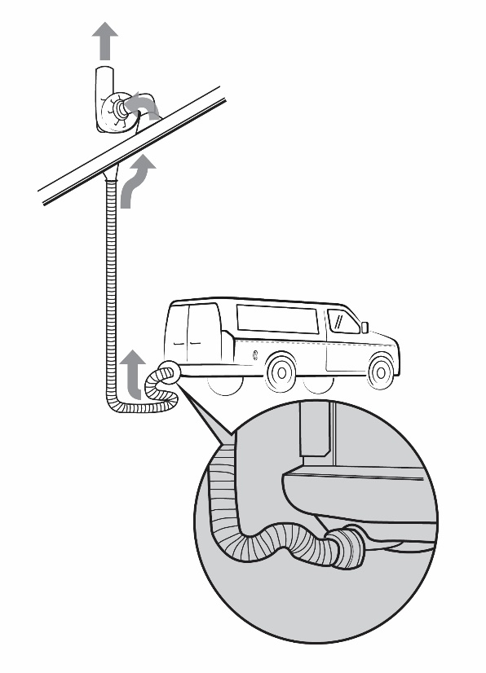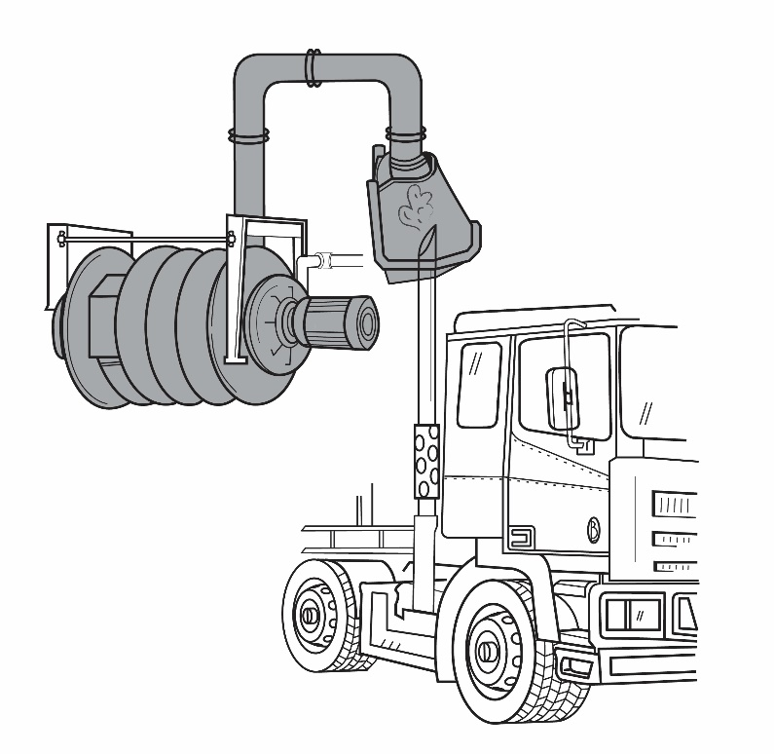
General ventilation
General ventilation can be natural ventilation or mechanical and is not as effective as LEV. Natural ventilation could consist of open windows and doors supplemented by floor fans. Mechanical ventilation could use fans to move air through the work area or to introduce a fresh air supply. General ventilation may be suitable for a small workshop with one or two vehicles.
Air entering via an open door or air supply inlet may be vented using general (natural) or mechanical roof extraction as illustrated in Figure 3. However, where open doors or windows provide the ventilation, in the winter they may be shut to conserve heat, leading to the potential build-up of engine emissions.
A combination of LEV and general ventilation can be used, for example tailpipe exhausts with open doors
or roof extraction.
Design of ventilation systems
The design of effective ventilation systems is a highly skilled area of expertise and should only be performed by those competent to do so. Ventilation inlets and outlets should not be blocked and should always be kept clear. Air from extraction exhausts should not be recirculated back into the work area or released close to air intakes or compressors supplying breathing air. Regular planned preventative maintenance of ventilation systems is essential.

Figure 3 Examples of what general ventilation in a workshop could consist of i.e. natural and mechanical
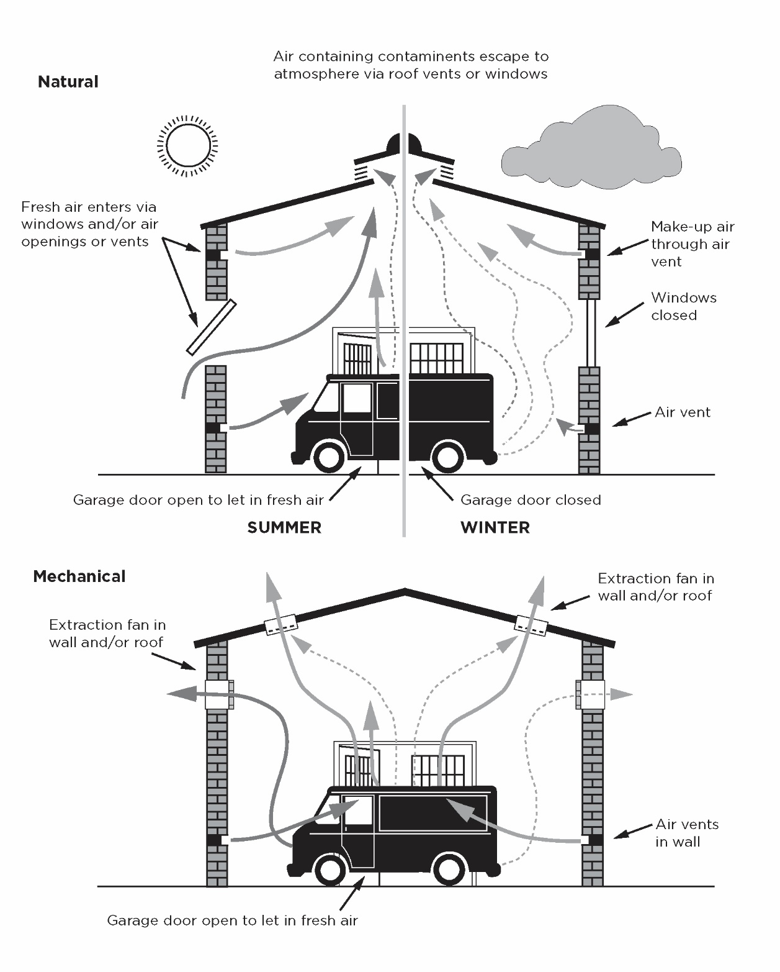
If after implementing the above control measures a risk still remains, consider the following controls in the order below to minimise the remaining risk, so far as is reasonably practicable:
  - Administrative controls for example:
- using processes or systems of work which will help you to reduce the generation of diesel exhaust, for example:
- switching off engines whenever possible, rather than leaving them idling, and
- adopting a programme of regular engine maintenance.
- where reasonably practicable, reducing the number of workers directly exposed and their period of exposure, for example:
- ensuring office staff working adjacent to diesel exhaust emission areas are not exposed
- job rotation, and
- scheduling work to minimise the number of workers near the plant while it is operating.
  - Using respiratory protective equipment
As exposure to diesel exhaust is best controlled at the source or by other means as described previously, respiratory protective equipment (RPE) should only be used as a last resort. In many cases it will not be appropriate to provide respirators to workers who are exposed to diesel exhaust, for example in situations like drive-through take-away food outlets.
The use of RPE may be appropriate in some situations however you should get advice from a competent person, for example an occupational hygienist if you are not sure.
Specific types of respirators must be used to prevent diesel exhaust exposure. P2 disposable respirators (Figure 4) may be suitable if the concentration of vapour in the diesel exhaust is low. Half or full-face respirators (Figure 5) with a filter cartridge that protect against gases, organic vapours and particles are generally more suitable.
Note: Air purifying respirators do not protect against all hazardous gases.
Figure 4 P2 disposable respirator
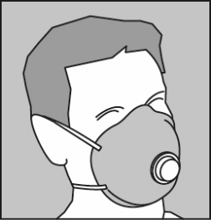
Figure 5 Half-face respirator
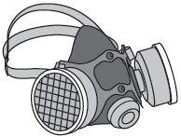

Respirators need to be properly stored, inspected, cleaned and maintained. Workers should be trained and fit-tested to use a respirator.
Further information on respirators is in:

AS/NZS 1715:2009: Selection, use and maintenance of respiratory protective equipment, and
AS/NZS 1716:2012: Respiratory protective devices.
A combination of the controls set out above may be used if a single control is not enough to minimise the risks.
4. Information, training, instruction and supervision must be given to workers on the health hazards associated with exposure to diesel exhaust emissions and on the proper use of control measures.
The information, training and instruction should enable workers to recognise obvious deterioration in the controls used (like poor maintenance of engines, damage to extraction equipment or ineffective general ventilation), so they can report to the people who would then take the necessary action to rectify the situation.
Information, training and instruction should include the following:
- the hazards and risks to the worker
- the control measures implemented, how to use and maintain them correctly, for example how and when to clean or replace filters
- the arrangements in place to deal with emergencies including first aid instructions, and
- the selection, use, maintenance and storage of RPE required to control risks and the limitations of the RPE.
Information, training and instruction must be provided in a way that it is easily understood. The amount of detail and extent of training will depend on the nature of the hazards and the complexity of the work procedures and control measures required to minimise the risks.
Supervision should be provided to ensure safety procedures are being followed, particularly where administrative control measures are used to minimise risks.
Records of training provided to workers should be kept, documenting who was trained, when and on what.
Minimising incidental exposure
To minimise worker exposure to diesel exhaust in situations where control over the source of diesel exhaust may not be possible, that is incidental exposure, the following risk control measures should be considered:
General Workers
Where applicable close down walkways or minimise public access to prevent exposure to diesel powered engines.
Plan work so it happens at the least busy time of the day or week to minimise the volume of diesel exhaust released into the work area.
Use portable extraction units where possible to move diesel exhaust away from workers in areas like tunnels or covered roadways/walkways.
Workers should be provided with training on hazards associated with diesel engines and methods to minimise diesel exhaust exposure in the workplace including the correct use of RPE if needed.
Booth Attendants
Many booths may not have mechanical ventilation. In these instances these booths should be sited in areas with good natural ventilation and easy vehicular access at all times.
Ticket openings on pay and toll booths need to be as small as commercially possible, to limit the amount of polluted air entering the booth. During quiet periods, for example when there are few vehicles, windows and doors may be open to allow free movement of air.
However, where there is always a high accumulation of emissions, the booths need to be kept under positive pressure and provided with sufficient fresh air supplied from an uncontaminated source. Use positive pressure ventilation to prevent diesel exhaust from entering work areas like toll booths.
Use automatic windows in air-conditioned toll booths and drive-through take away food booths to minimise the potential for diesel exhaust to enter the work area.
A combination of adequate ventilation and closed serving windows will achieve the best possible reduction in exposure.
Workers should be trained in specific control procedures like shutting service windows when not actively handling items through the windows, to minimise exposure to diesel exhaust.
Reviewing and maintaining control measures
Control measures should be reviewed regularly to make sure they are effective, for example checking the airflow and filters in ventilation systems. Reviewing risk control measures may include inspecting the workplace, consulting workers, testing and analysing records and data. It also involves considering whether the use of a higher order control measure is now reasonably practicable.
Control measures must be reviewed and if necessary revised:
- when the control measure is not effective in controlling risk
- before a change at the workplace that is likely to give rise to a new or different health and safety risk
- if a new hazard or risk is identified
- if the results of consultation indicate a review is necessary, or
- if a health and safety representative or worker requests a review.
Control measures must be reviewed at least once every 5 years. If a person conducting a business or undertaking has concerns they should go back through the risk management steps, review the information and make decisions about control measures.
You should ensure that all the measures provided to control exposure to diesel exhaust emissions in the workplace are maintained in an effective state and kept in efficient working order and in good repair. Where engineering controls are used, they should be thoroughly examined and tested at regular intervals.
With the exception of disposable filtering facepiece respirators intended for single shift use, RPE should not be used unless it has had a recent thorough examination and maintenance.

Do I need to measure diesel exhaust?
There is no workplace exposure standard for diesel exhaust. Some of the individual components of diesel exhaust like carbon dioxide, carbon monoxide and inhalable or respirable dust can be monitored to provide an indication of diesel exhaust levels.
Air monitoring may be used to:
- determine if there is a failure or deterioration of the control measures
- determine when there is potential for diesel exhaust to build up in the work place, and
- check the effectiveness of control measures provided e.g. particulate filter, LEV, general ventilation and RPE.
If it is obvious there is a problem, for example when workers report adverse health effects including headaches, dizziness, nausea or irritation of the eyes, nose or throat, control measures must be reviewed immediately.
Workplace air monitoring should be done with advice from a competent person like an occupational hygienist. Air monitoring for diesel exhaust emissions involves using specialist equipment and measuring techniques.
Mining regulators in a number of Australian jurisdictions and the Australian Institute of Occupational Hygienists (AIOH) recommend that exposure to diesel particulate matter is kept below of 0.1 mg/m³ time-weighted average over 8 hours (measured as sub-micron elemental carbon). Elemental carbon is the core component of DPM. This recommendation is based primarily on minimising the irritant effect of DPM.
For further information on control of diesel exhaust in specific situations like workshops, railways and toll booths see the Health and Safety Executive’s Control of diesel engine exhaust emissions in the workplace.
Further information on compliance with exposure standards and the need for air monitoring is in:
- Workplace exposure standards for airborne contaminants, and
- Guidance on the interpretation of workplace exposure standards for airborne contaminants.

Further information
- Health and Safety Executive, United Kingdom, Control of diesel engine exhaust emissions in the workplace, 3rd ed, 2012.
- Peters, S, Carey RN, Driscoll TR, Glass DC, Benke G, Reid A, Fritschi L, The Australian Work Exposures Study: Prevalence of Occupational Exposure to Diesel Engine Exhaust, Ann. Occup. Hyg., Vol 59 (5) June 2015, pp. 600-600, Oxford University Press.
- Management of diesel emissions in Western Australian mining operations, Government of WA, Department of Mines and Petroleum Resources Safety, 2013.
- US Occupational Safety and Health Administration, Hazard Alert, Diesel exhaust/diesel particulate matter, OSHA, 2013.
- Health and Safety Laboratory (United Kingdom), Controlling and monitoring exposure to diesel engine exhaust emissions in coal mines, HSL, 2005 (PDF 367.21kb)
- Australian Institute of Occupational Hygienists, Diesel particulate matter & occupational health issues, Position paper, AIOH, 2013 (PDF 853.04kb)
- United States Environment Protection Agency, Health assessment document for diesel engine exhaust, EPA, May 2002
- Diesel emissions in mines – Safety Bulletin, NSW Government Trade & Investment, Mine Safety, 2013 (PDF 88.8kb).
- Safe Work Australia, Guidance on the interpretation of workplace exposure standards for airborne contaminants, 2013.
- AS/NZS 1715:2009: Selection, use and maintenance of respiratory protective equipment.
- AS/NZS 1716:2012: Respiratory protective devices.
- Method 5040 - Diesel Particulate Matter (as Elemental Carbon). NIOSH Manual of Analytical Methods, Fourth Edition, 2003.

Contains information from Control of diesel engine exhaust emissions in the workplace, HSG187 3rd edition, Health and Safety Executive, 2012 © Crown copyright information licenced under the Open Government Licence www.nationalarchives.gov.uk/doc/open-government-licence/version.
For example: Management of diesel emissions in Western Australian mining operations, WA Department of Mines and Petroleum Resources Safety, or Safety Bulletin - Diesel emissions in mines, NSW Government, Trade and Investment Mine Safety.

